CHAPTER 2 HOMEWORK

1. The following data give the results of a sample survey. The letters A, B, and C represent the 3 categories:

A | B | B | A | C | B | C | C | C | A
C | B | C | A | C | C | B | C | C | A
A | B | C | C | B | C | B | A | C | A

- Prepare a frequency distribution table
Category | Frequency
A | 8
B | 8
C | 14
Total | 30

- Calculate the relative frequencies for all categories
Category | Frequency | RF
A | 8 | 0.267
B | 8 | 0.267
C | 14 | 0.467
Total | 30 | 1.000

- What percentage of elements in this sample belong to category B?
0.267*100%
= 26.7%

- What percentage of elements in this sample belong to category A or C?

(0.467+0.267) *100%
= 73.37%

- Draw a bar graph for the relative frequency distribution

2. The data on the status of 50 students are given (F=Freshman, SO=Sophomore, J=Junior, SR=Senior):

J | F | SO | SR | J | J | SR | J | J | J
F | F | J | F | F | F | SR | SO | SR | J
J | F | SR | SO | SO | F | J | F | SR | SR
SO | SR | J | SO | SO | J | J | SO | F | SO
SR | SR | F | SR | J | SO | F | J | SO | SO

- Prepare a Frequency distribution table.
- b. Calculate the relative frequencies or all categories

Status | Frequency | RF
Freshman | 12 | 0.24
Sophomore | 12 | 0.24
Junior | 15 | 0.30
Senior | 11 | 0.22
Total | 50 | 1.00

- What percentage of these students are juniors or seniors?

(0.30+0.22 )*100%
=52%
d. Draw a bar graph for the relative frequency distribution.

3. The following table gives the frequency distribution of ages for all 50 employees of a company:

Age | Number of Employees
18 to less than 31 | 12
31 to less than 44 | 19
44 to less than 57 | 14
57 to less than 70 | 5

a. Find the class midpoints
Age | Midpoint
18-30 | 24
31-43 | 37
44-56 | 50
57-69 | 63

b. Do all the classes have the same width? If yes, what is that width?
Yes. The class width is 12
cPrepare the relative frequency distribution column

Age | Number of Employees | RF
18 to less than 31 | 12 | 0.24
31 to less than 44 | 19 | 0.38
44 to less than 57 | 14 | 0.28
57 to less than 70 | 5 | 0.1

- What percentage of the employees of this company are less than 44 years old?

(0.38+0.24) *100%
= 62%

- Prepare the cumulative frequency distribution & relative cumulative frequency distribution columns.
Age | Number of Employees | CF | RF | CRF
18 to less than 31 | 12 | 12 | 0.24 | 0.24
31 to less than 44 | 19 | 31 | 0.38 | 0.62
44 to less than 57 | 14 | 45 | 0.28 | 0.90
57 to less than 70 | 5 | 50 | 0.1 | 1.00

- Construct an ogive for this data.
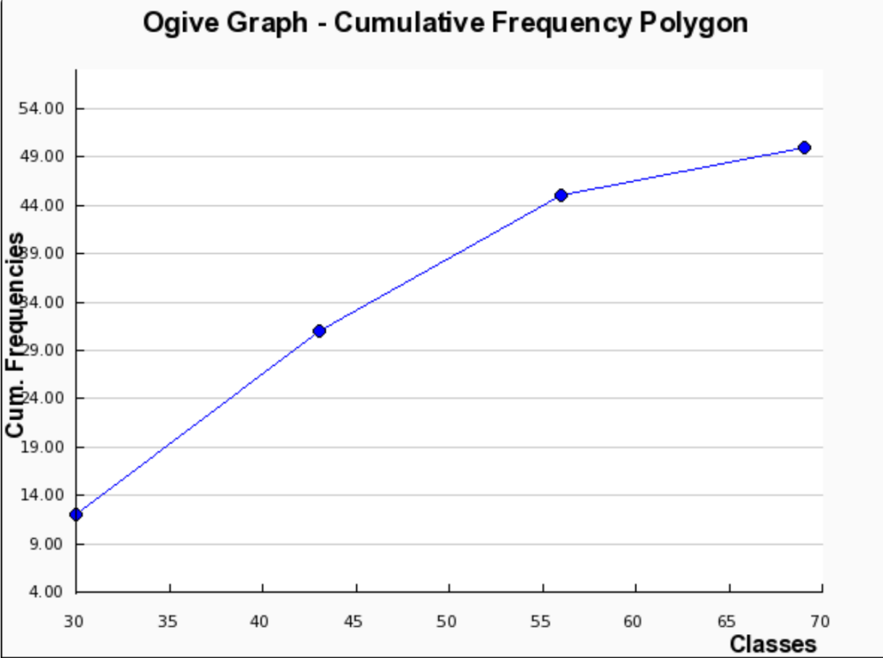

g. Estimate the percentage of employees that are less than 35 years old.
18%
4. Nixon Corporation manufactures computer monitors. The following data are the numbers of computer monitors produced at the company for a sample of 30 days:

24 | 32 | 27 | 23 | 33 | 33 | 29 | 25 | 23 | 28
21 | 26 | 31 | 22 | 27 | 33 | 27 | 23 | 28 | 29
31 | 35 | 34 | 22 | 26 | 28 | 23 | 35 | 31 | 27

- Construct a frequency distribution table using the classes 21-24, 24-27, 27-30, 30-33, and 33-36
- Calculate the relative frequencies, cumulative frequencies, and relative cumulative frequencies of this data.

No. of Computers | Frequency | CF | RF | CRF
21-23 | 7 | 7 | 0.233 | 0.233
24-26 | 4 | 11 | 0.133 | 0.366
27-29 | 9 | 20 | 0.300 | 0.666
30-32 | 4 | 24 | 0.133 | 0.799
33-35 | 6 | 30 | 0.200 | 1.000
Total | 30 |  | 1.000

- Construct a relative frequency histogram for this data.

- Construct a relative cumulative frequency ogive for this data.

5. Following are the total yards gained rushing during the 2005 season by 14 running backs of 14 college football teams:

745 | 921 | 1133 | 1024 | 848 | 775 | 800
1009 | 1275 | 857 | 933 | 1145 | 967 | 995

Prepare a stem-and-leaf plot.

Key: 75|2 = 752
75|45 = 745

Stem | Leaf
70 | 45 75
80 | 0 48 57
90 | 21 33 67 95
100 | 9 24
110 | 33 45
120 | 75

6. The following data give the money (in dollars) spent on textbooks by 35 students during the 2005-2006 academic year:

565 | 528 | 270 | 220 | 245 | 368 | 210
265 | 50 | 345 | 530 | 705 | 490 | 158
320 | 505 | 457 | 478 | 617 | 721 | 635
438 | 475 | 702 | 538 | 720 | 460 | 540
390 | 560 | 570 | 706 | 430 | 268 | 638
Prepare a stem-and-leaf display for this data.
Key: 5|50 = 550

Stem | Leaf
0 | 50
1 | 58
2 | 10 20 45 65 68 70
3 | 20 45 68 90
4 | 30 38 57 60 75 78 90
5 | 05 28 30 38 40 60 65 70
6 | 17 35 38
7 | 02 05 06 20 21

7. The following table gives the percentage of 12th-graders who smoke from 1975 to 2004:

Year | Percent | Year | Percent | Year | Percent
1975 | 36.7 | 1985 | 30.1 | 1995 | 33.5
1976 | 38.8 | 1986 | 29.6 | 1996 | 34.0
1977 | 38.4 | 1987 | 29.4 | 1997 | 36.5
1978 | 36.7 | 1988 | 28.7 | 1998 | 35.1
1979 | 34.4 | 1989 | 28.6 | 1999 | 34.6
1980 | 30.5 | 1990 | 29.4 | 2000 | 31.4
1981 | 29.4 | 1991 | 28.3 | 2001 | 29.5
1982 | 30.0 | 1992 | 27.8 | 2002 | 26.7
1983 | 30.3 | 1993 | 29.9 | 2003 | 24.4
1984 | 29.3 | 1994 | 31.2 | 2004 | 25.0

a. Plot the Percentage of smokers as a time series

b. Does the data indicate a trend?
downward until 1992, then up to 1997, then down again

Selected Answers:
1c – 26.7% 1d – 73.4% 2c --- 52%
3d – 62% 7b –

